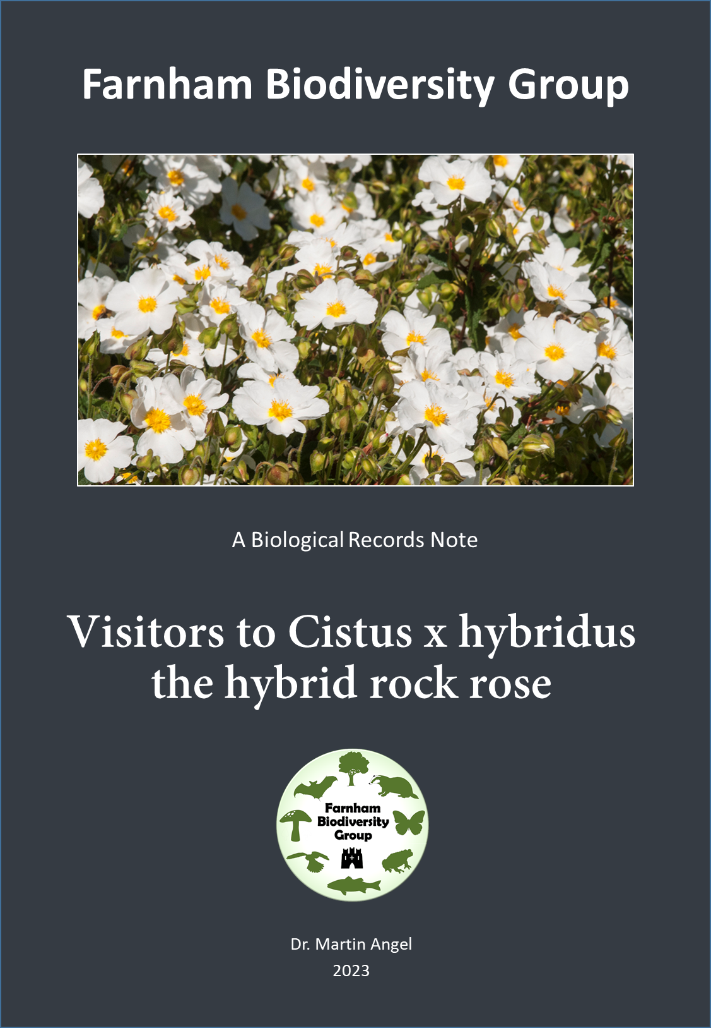
Visitors to Cistus x hybridus - the hybrid rock rose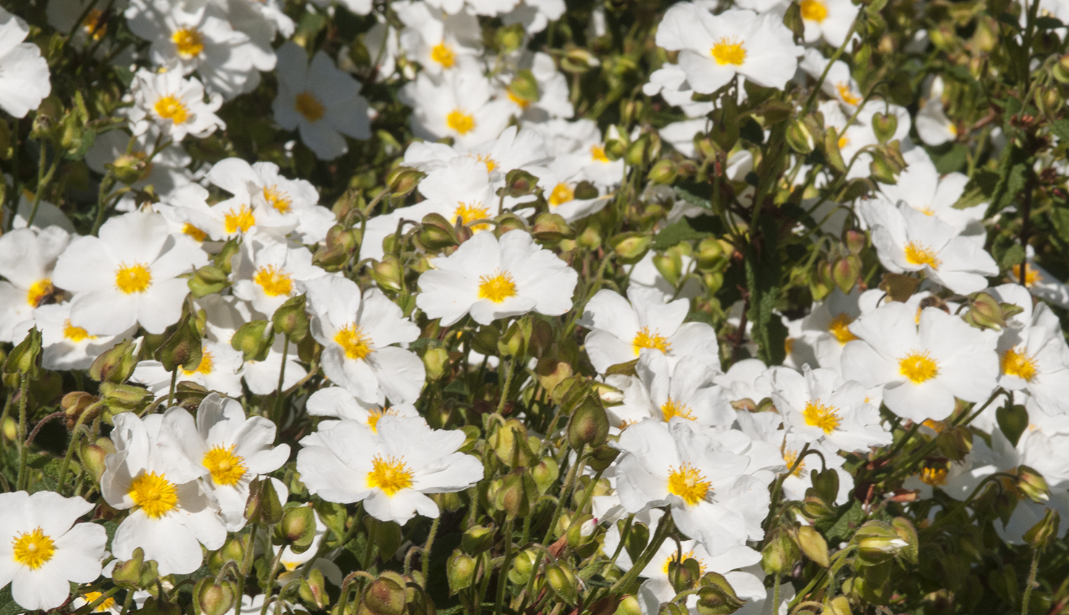

When we moved into our house in autumn 2017, we knew nothing about the plants in the garden. We were not very enthusiastic about a rather boring looking low growing evergreen shrub at one end of the garden. However, with so many other more compelling tasks to undertake, we left dealing with this apparently unglamorous plant until the following spring. At the beginning of May the next year, it underwent a dramatic transformation, it became a spectacular sight entirely covered with open white flowers with bright orange-yellow centres. Perhaps, the only minor drawback was that the flowers which opened in the morning, began to shed their petals mid-afternoon, and by early evening all were gone. However, the next morning a fresh crop of flowers had opened and this daily cycle continued through until the first week in June. When in full bloom, the flowers attracted such a large array of insects collecting pollen and nectar that their buzzing was audible even to my rather deaf ears. Since no one seemed to recommend this shrub as encouraging pollinators, I began a personal project of photographically recording the diversity of visitors. This article summarises the results. Perhaps my only personal reservation is that because at mid-afternoon the flowers begin to drop their petals and all have dropped by evening, the shrub is no longer attractive to nocturnal pollinators, hence almost no moths. The majority of the visitors are insects collecting either nectar or pollen, but a few either prey on the others or merely eat the petals and the anthers.

Hymenoptera – bees and wasps
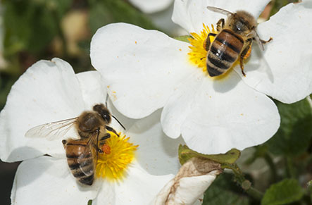
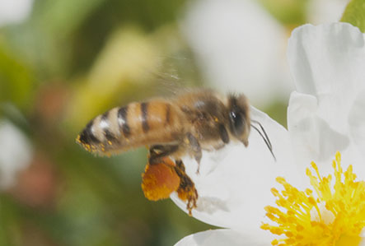
The pollinator most familiar to people is the honey bee Apus mellifera. Honey bees visit the Cistus for both nectar and the profuse qualitities of yellow pollen produced by the ring of stamens at the of the flowers. The numbers of honey bees visiting is very much dependent the weather but also on how close the nearest hives are to the garden and whether there are other rewarding flowers in other gardens along the flight path. Those that are collecting the pollen, which is used to provide essemtial protein to the developing grubs back in the hive,. They pack the pollen into the pollen baskets on their hind legs, and the colour of the pollen in a bee’s basket can be a good indicator of which types of flower the bee has been visiting. Bees can be seen hovering over the flower they have just been visiting tamping down the pollen in the basket (as in the lower photograph).

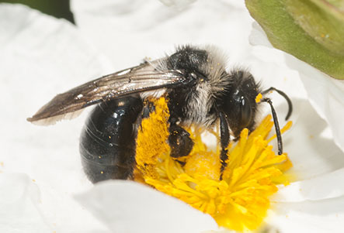
Ashy mining bee Andrena cineraria is a distinctive large solitary mining bee that is quite common in the South of England. It is found in quite a range of habitats, but it prefers nesting in sandy soils with short turf on south facing slopes. It exploits a wide variety of species of spring flowers, and is one of the commoner of the solitary mining bees that excavate their nesting holes in lawns.

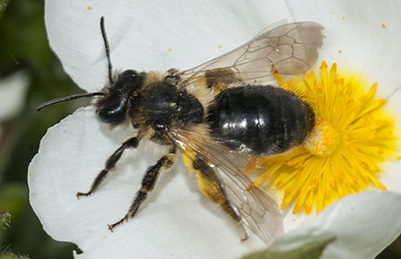
Big-headed mining bee Andrena bucephala is another of the mining bees that is only slight;y smaller than a honey bee. This springtime bee is all black except for the characteristic clumps of white hairs on the rear corners of the thorax. It is predominantely a species of chalk or limestone countryside that exploits flowering hawthorn and field maple. Note how it is carrying pollen stuck to its hind legs, but not in pollens baskets as seen in honey bees.

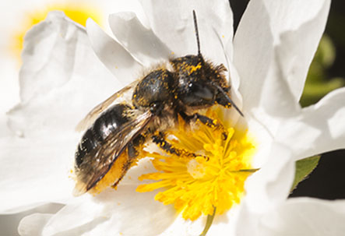
Chocolate mining Bee Andrena scotica is the most abudant mning bee in our garden. It nests in small aggregations in burrows it excavates in cracks in the concrete path along one side of our house. It hosts a cleptoparasitic bee Nomada marshamella, a colourful species which also ocassionally turns up on the Cistus flowers.

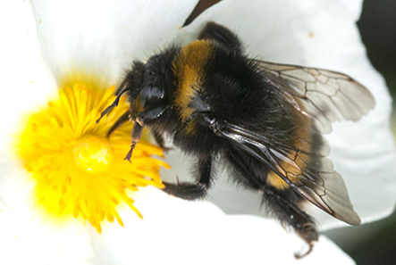
Buff-tailed bumblebee Bombus terrestris is one of the commonest bumblebees in Southern Britain and occurs throughout most of the British Isles. It is also one of the largest – queens are 18mm long and workers are 13mm. It is one of the ealiest species to appear in February and persists into the autumn by produseing two generations. It nests underground in large colonies, usually in old rodent burrows. It is an important pollinator

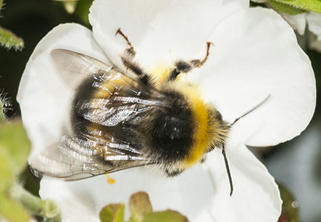
Vestal cuckoo bee Bombus vestalis is easily mistaken for a buff-tailed bumblebee of which it is a nest parasite. It is the commonest cuckoo bee in our area, and like their host species occur from March until late September. It does not have a pollen basket on the hind legs, since it relies on its host to feed their developing larvae.

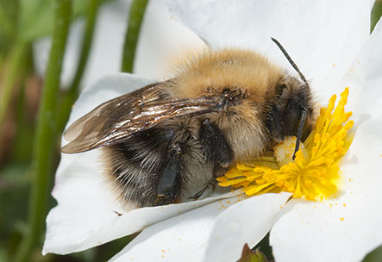
Common carder bee Bombus pascuorum is another very common bumblebee in our garden and elsewhere in suburban and urban areas. The queens are 13mm long and start appearing towards the end of March and are still around into October. They usually nest on the ground in amongst grass tussosks but will take up residence in bird boxes. It is the main host of the field cuckoo bee Bombus campestris.

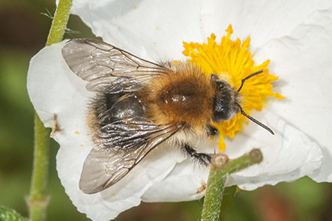
Tree bumblebee Bombus hypnorum is a medium-sized bumblebee that is immediately recognisable by its gingery thorax. It is a recent addtion to the British fauna – first arriving in Britain n 2001, but has rapidly colonised England and Wales. Queens first appear in March and there are two generations a year. It nests above ground, in tree holes, old bird boxes and under the eaves of houses. They hav become one of our more important pollinators.
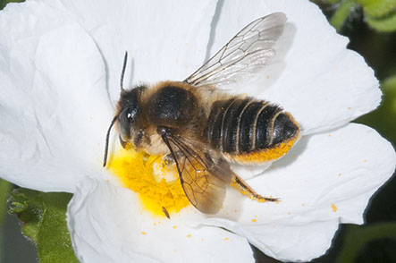
Patchwork leaf-cutter bee Megachila centuncularis is a medium-sized leafcutter that has an orange halo of pollen hairs around the underside of its abdomen. Its flight seeason is mid-June to September so it only just coincides with the flowering season of the Cystus. They nest in wall cavities and bee hotels lining them with semicircles of leaves they cut from a variety of plants but often cut from rose bushes.

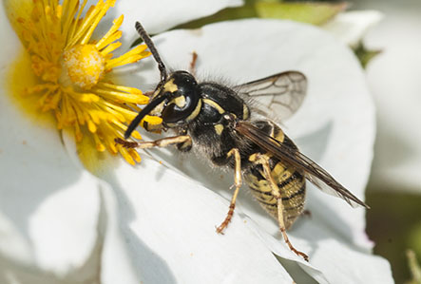
Common wasp Vespula vulgaris exploit the flowers both for pollen and nectar but also as a hunting ground for predating other insects. There are seven species of social wasp in England which can only be reliably identified if examined head-on. As predators they provide an important service of peat control in gardens, but can also be painful pests if you have to cross their flight path. Common wasps nest undergraound, but other species may nest in houses and trees.

The flies – Diptera
Flies have an evil reputation as vectors of disease, but flies also provide significant ecological services by cleaning up our environments – without them we would be knee deep muck and rotting organic matter. But they also provide other essential services such as the pollination of our flowers.

Hoverflies; Many are good pollinators, and others are excellent pest controllers. But there are a few that are garden pests such as the narcissus fly.
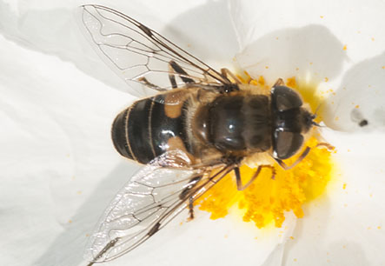
One of ther drone flies - Eristalius nemorum is one of the smaller ones that are very common in our countryside and gardens. One behavioural trait that immediately identifies this species is that males hover 10-20cm above females feeding on flowers. Like all Eristalis this species has larvae that are rat-tailed maggots that live in organically rich slurries. They have telescopically extensible siphons which enable them to get oxygen from the air even in the most anoxic soups.

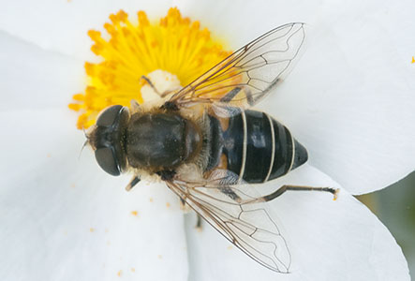
Hoverfly Eristalis arbustorum is another of the smaller drone flies that is common in gardens. It is a good pollinator of many types of flower. It too has a larva that is a rat-tailed maggot that can even live in cow-pats as well as highly polluted drains and ponds. The cross lines on the abdomen are brighter and clearer than othe members of the genus.

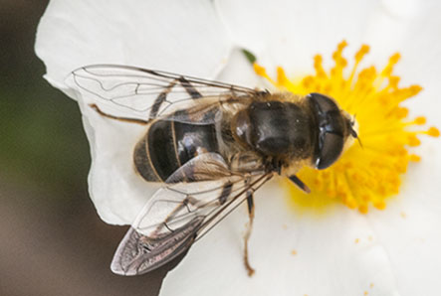
Hoverfly Eristalis pertinax is one of the larger species drone flies. It is one of the earliest hoverflies to appear in the Spring. When the Cistus comes into flower it is at its most abundant. It is easily distinguished from the other species by the tarsi (the end segments of its forlegs being entiely orange. Otherwise like all the members of the genus its body markings on the body are veryt variable, so its identification is quite tricky.

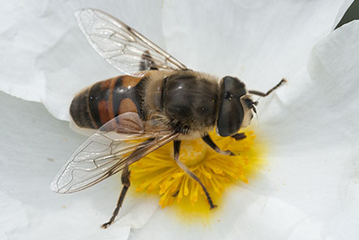
Hoverfly Eristalis tenax is another of the larger common species of dronefly. It is quite a good mimic of a honey bee, and when it hovers its hind legs dangle and when ressemble the pollen baskets of the bees. Even in late autumn it can be quite an abundant fly feeding on Michaelmas daisies. It will sometimes overwinter in houses and so can be encountered at almost any time of year.

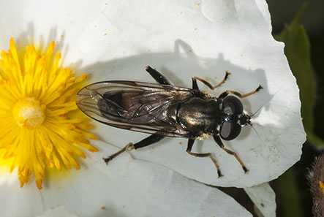
Hoverfly Cheilosia proxima is one of the dark species of hoverfly that are extremely tricky to identify. In the UK there are nearly 40 species of the genus. Their larvae feed on plants in this species the larvae feed on the roots of thistles.

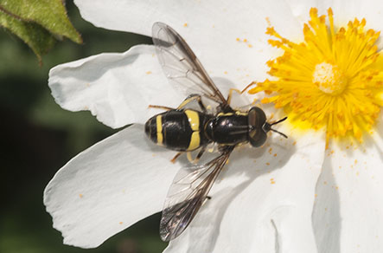
Hoverfly Chrysotoxum bicinctum is a widespread and quitee common hoverfly. It is immediaely recognisable because of its unique attribubute of having just two yellow bands on its abdomen, but there is the possibility that further study may show there is more than one species with this attribute. Its larvae feed on root aphids. Note the long dark line on the front edge of the wings and the long antennae.

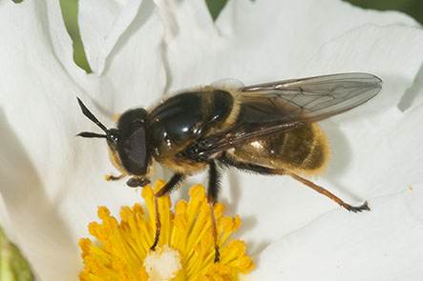
Hoverfly Callicera aurata is an uncommon hoverfly that breeds in water-filled rot-holes high up in trees. It has a resemblence to bees, but its log antennae are a give away. It is one of the less common hoverflies that has visitied our Cystis.

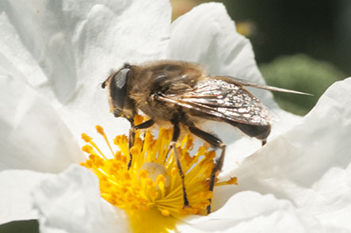
Hoverfly Criorhina floccosa is a furry bunblebee mimic which is common in the south of England. Its larvae occur in the rotting heart wood in the wet rot in tree stumps and roots.

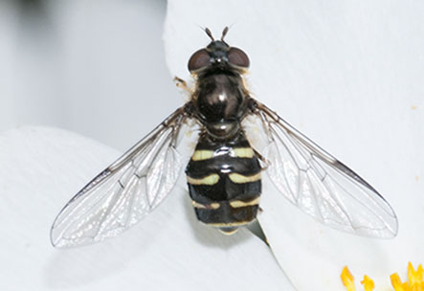
Hoverfly Dasysyrphus venustus is a common species with hooked yellow bands across the abdomen. Its face (frons) is entiely black and the black antennae are tioed with yellow. Their well-camouflaged spiky bodied larvae live on the twigs and braanches of woodland trees, where they prey on aphids.

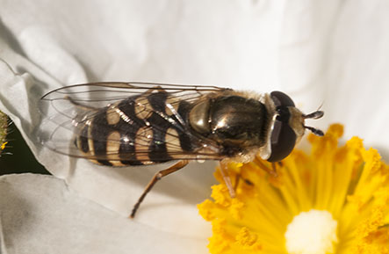
Hoverfly Eupeodes corollae is one of our most common hoverfly species whose populations in most years is boosted by migratiosn from mainland Europe. In some years there may be mass hatchings which boost the populations still further in midsummer. Its larvae eat ground-living aphids. The males differ from the females by having squarer abdominal yellow commas.

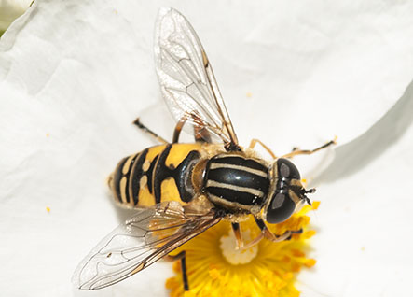
Hoverfly Helophilus pendulus is widespread and common species around ponds and ditches, but it does waander a long way from water. It wil be seen quite frequently sunning itself on the leavesof shrubs. There are three very similar species which are commonly known either as ‘footballers’ or as ‘tiger-flies’. Their larvae are found in water where they feed on plant debris.

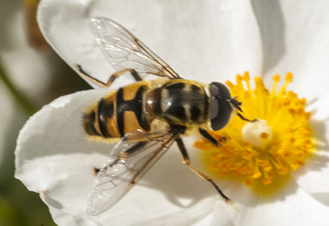
Hoverfly Myathropa florea is readily distinguished from Helophilus by the banding on the thorax being horizontal rather than longitudinal. It is another common species that is regarded as a wasp mimic. Its larvae occur in rot-holes in wood especially those filled with decaying leaves. The males will often hover one or two metres above the ground in sun-spots.

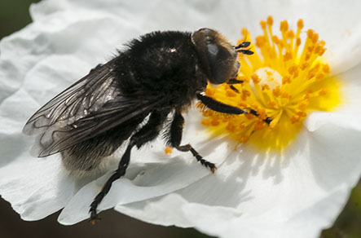
Large Narcissus fly Meredon equestris is a large very variable hoverfly that is most common in late Spring/early Summer. It is a large hairy bumblebee mimic which is very variable in colour depending on which bumblebee species it is mimicing, However, its legs are entiely black. It can be a serious horticultural pest becaise ite larvae attack the bulbs of daffodils and bluenells.

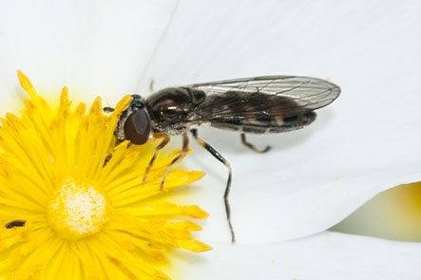
Hoverfly Platycheirus species-there are at least 22 species belonging to this genus in Britain which are very difficult to distinguish. P. albimanus is one of the most abundant in our woodlands and gardens. Its larvae are predators of aphids, and so are contributing to the natural control of some of our pest species.

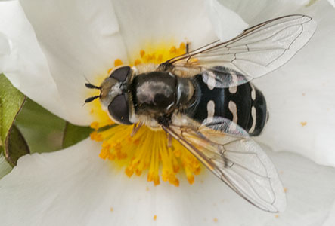
Hoverfly Scaeva pyrasti is a large conspicuous hoverfly whose abunadance varies from year-to-year. It not a resident species in this country but breeds here after it has migrated in from continental Europe, usually after the beginning of June. Thus years like 2023 when the springtime winds are persisenly northerly, it has not very abundant. The larvae are found preying on ground-layer aphids.

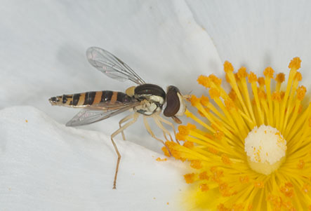
Hoverfly Sphaerophoria sp Is a small slim easily recognised genus but which is challenging when it come to identifying its thitrteen or so species. A task made all the mor difficult by more than one species may be flying together at the saame time. This specimen with its wings shorter than the abdomen is probably S. scripta. The larvae feed on ground dwelling aphids. Like many species in most years the populations get boosted by migrations from continental Europe.

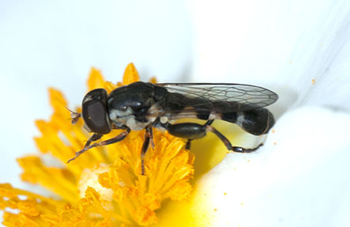
Hoverfly Sphegina clunipes is a species that prefers shade in woodland to sunlight in the open, hence it was unexpected to see it on our Cistus. Relatively few species of hoverfly have the narrowed waists, and the swollen hind femurs that are typical of this genus. Its larvae are found under decaying bark feeding on the fermenting sap.

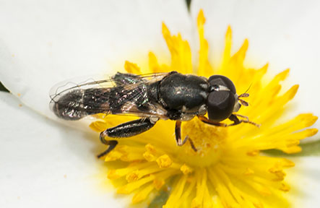
The thick-legged hoverfly Syritta pipiens is a widely dispersed species which has hind legs with swollen spiny femurs. The abdomen is parallel-sided with lateral orange patches. It breeds in compost heaps and other piles of rotting organic matter. They are common in urban areas as well as more natural environments.

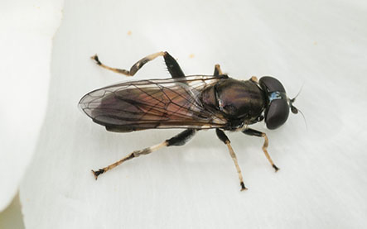
Hoverfly Xylota segnis is a familiar sight runnning over leaves and logs in woodlands and gardens. It is one of the species with enlarged but straight femurs on the hind limbs. The abdomen is parallel-sided and in this species has an reddish-orange belt. It breeds on wet rotten wood in woods, hedges and even gardens.

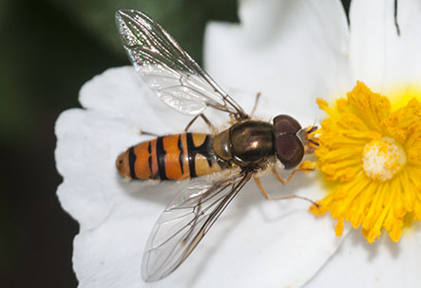
Marmalade hoverfly Episyrphus balteatus I probably the most widespread and common hoverfly in Britain. It can turn up in any month of the year, even in midwinter when the weather is mild. It is one of the few hoverflies that has a colloquial name. Populations of this hoverfly are regulalry boosted by migrations from the Continent. However, such migrations are highly susceptible to vagaries of the weather - in May 2022 there was a mass stranding of this species wass recorded on a beach in Southern France.

Other Flies
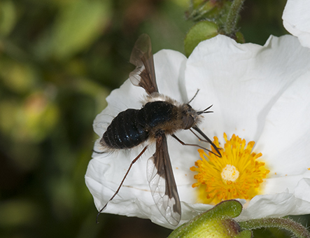
Bee fly Bombylius major is an early spring fly which is nearly at the end of its season by the time the Cystis flowers. Many people mistakenly identify its long proboscis as a sting, whereas it is used to suck nectar from tubular spring flowers such as primroses. It has a very curious life history. The female scatters her eggs near the entrance to bee nests. The larvae that hatch cling on to passing bees, gaining access to the nest. There it lives feeding on debris in the nest. They are highly effective pollinators of spring flowers.

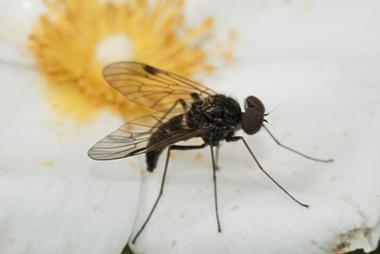
Black snipefly Chrysopilus cristatusBis a widespread fly species in Britain. It is carnivorous preying on other small insects. It is probably using the flower as an observation post for its hunting rather than exploiting it for nectar or pollen.

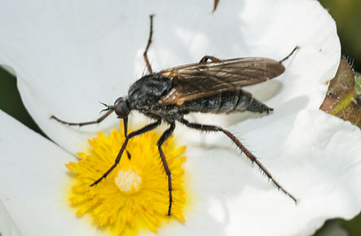
Dance fly Empis tessellata is another common predatory fly seen on garden plants. It preys on other insects piercing them with its long dagger-like mouth part, but is also uses it to suck nectar from flowers. its larvae are also predaceous.

Beetles - Coleoptera
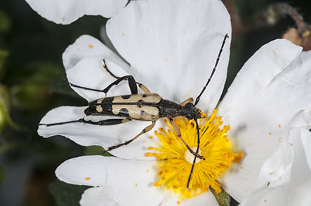
Black and yellow longhorn beetle Rutpela maculata is a common visitor to flowers in summer, especially to hogweed flowers, feeding on pollen and nectar. Like most longhorn beetles their larvae live in rotten wood and they take a couple of years to mature. There a couple of other longhorn beetle species that superficially look similar in having black and yellow bodies and also feed on flowers but their colour patterns are different. Despite having warning black and yellow colours they are quite harmless.

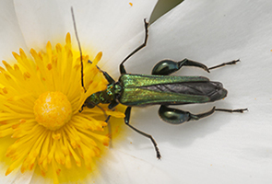
Thick-legged flower beetle Oedemera nobilis is a very common visitor to flowers throughout summer viviting flowers and feeding on pollen. It is the males that have the swollen ‘thighs’; the thighs of the females are unswollen. The larvae develop inside the stems of a variety of plants including thistles.

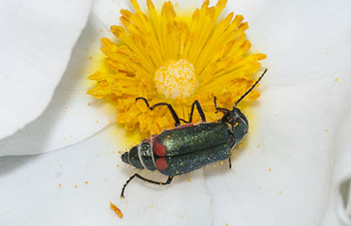
Th malachite beetle Malachius bipustulatus is another common summertime visitor to flowers, feeding on pollen. The conspicuous two red spots on the end of the elytra are only seen on one other smaller beetle. They lay their egg in crevices in bark or in grass tussocks. The larvae are predaaceous on other small insects.

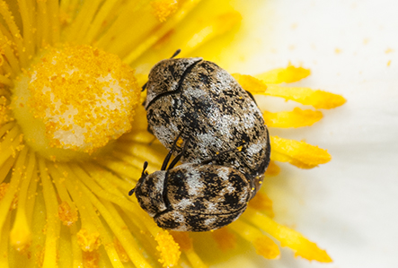
Demestid beetles Anthrenus verbasci are very common small beetles that feed on pollen. Unfortunately they will also enter houses where their larvae can become quite serious pests eating the natural fibres in carpets and underlays, hence they are called carpet beetles. In museums the can cause serious damage to the specimens on display, Theit larvae are small (3-4mm long) furry grubs sometimes calle wooly bears. They will be common visitors to your garden flowers.

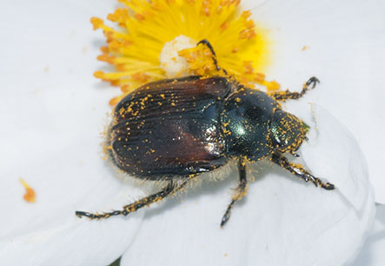
Garden chafer Phyllopertha horticola is a very common small chafer whose larvae feed on the roots of grasses and often have mass hatchngs from lawns. Their green thoraxes and bronzy elytras make them immediately recognisable. Along with all the flower-visiting beetles they fly readily espeially on warm sunny summer days. Notice how this one has got covered with pollen.

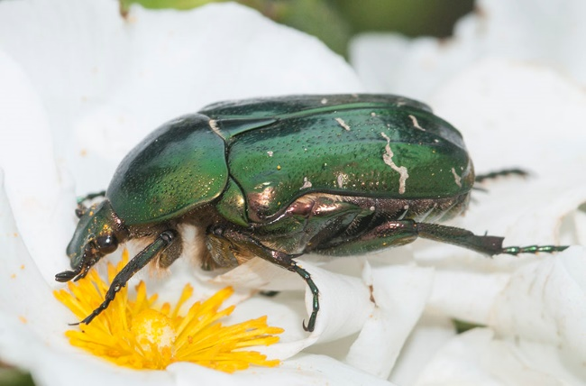
Rose chafer Cetonia aurata is a large spectacullar chafer beetle that flies in sunshine on warm summer days. It is related to maybug and has an evil reputation amongst rose growers. It certainly eats large holes in petals reducing the saleability of the flowers and this is used as an excuse to use insecticides. Their larvae live in compost heaps and take two years to mature. The shining green colour of the elytra is a structural collour and is produced like the colour of an oil film on water and is not by a pigment.

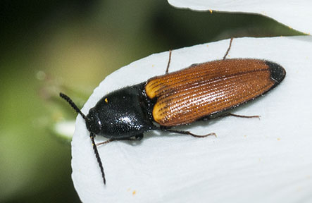
Click beetle Athous haemorrhoidalis is one of the commonest click beetles, so called because they can produce a loud click and leap into the air by flexing the abdomen against the thorax. Their larvae are wire worms. Some wire worms are predaceous but other are notorious for cause considerable damage to the roots of crops and unsightly brown patches in lawns. The adults are good fliers and are attracted to lights.

Lepidoptera – Butterflies
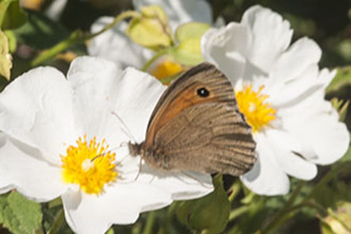
Meadon brown Maniola jurtina is a very common early summer butterfly that gets replaced by gatekeepers later in the summer. It usually appears in the second week of June and marks the beginning of the summer season. Rather surprisingly it is the only butterfly I have seen coming to the Cistis.

Lapidoptera – Moths

Relatively few moths are day flying and so only a very species that will visit the Cistus flowers.

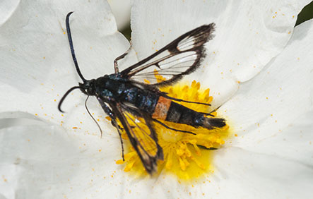
Red-belted clearwing Synanthedon myopaeformis. Clearwing moths are uncommon day-flying moths. They have larvae that live under the bark of trees that are damaged including apple, pear, hawthorn and rowan. This is a nationally scarce species which means that has been recorded in fewer than a hundred 10km squares. They are usually recorded by using pheromone traps, which use chemical attractants to draw in the moths.

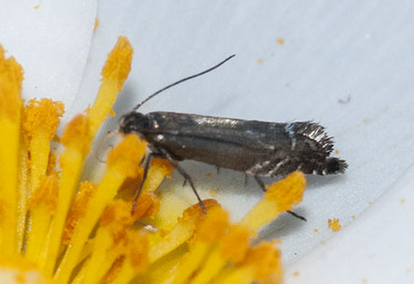
Cocksfoot moth Glyphipteryx simpliciella is a common tiny day-flying micromoth that is usually found in summer on buttercup and germander speedwell. Although It is widespread in Surrey it is probably underecorded because it is so tiny. Its caterpillars feed on the seeds of cocksfoot grass.

Bugs – Hemiptera
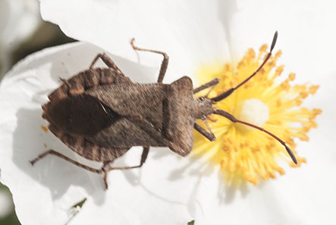
Dock bug Coreus marginatus is the most abundant large bug in our garden. Strictly speaking it is not a shieldbug because its antennae have four rather than five segments. The main peak in its abundance is in May when it can often be seen sunning it self on the leaves of shrubs, and mating pairs are common. Hemiptera have tubular mouthparts which they use to pierce plant tissue and suck up the sap. But there are also several carnivorous species especially in the tripics that suck blood – one British example Is the bed bug

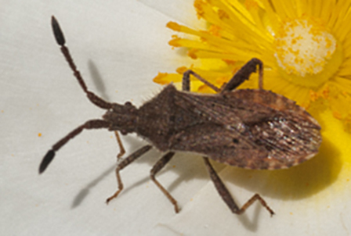
Coreid bug Coriomeris denticulatus is an uncommon bug in Surrey that is usually found on dry soils, so its occurrence in our clay-soiled garden was unexpected. It prefers the disturbed ground which the leguminose plants it feeds on can colonise. It flies readily emitting and when it does there is a flash of red from its abdomen as it takes off.

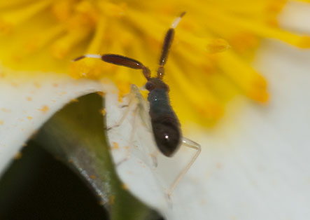
Juvenile mirid bug Heterotoma planicornis with its characteristicaally out-sized antennae – is more usually found on nettles. At this juvenile stage it has not developed wings and cannot fly, so it must hav hatcheed from an egg laid on the Cistis. It feeds not only on pollen but aslo other small insects. Adults occur in July, but I still have not identified any in the garden.

Arachnids – spiders

It is unsurprising that such rich diversity of insects which are potential prey species attracts predators which do not exploit the flowers’ resouces directly. What is surprising is that there are not more of them. Possibly this is because the flowers are relatively ephemeral, hence most web-builders do not find sites worth investing in, nor do the flowers last long enough to attract the stalkers, like crab spiders.

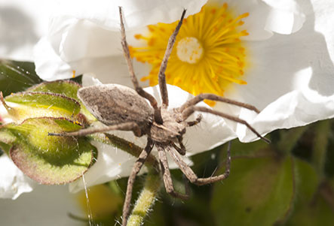
Nursery web spider Pisaura mirabilis is a very common large spider that wanders over low vegetation. Later in the summer the females carry egg cocoons – hence their common name. They also like to sun-bathe. They stalk their prey and only use silk to hold their egg cocoons and to weave protective tents for their developing offspring.

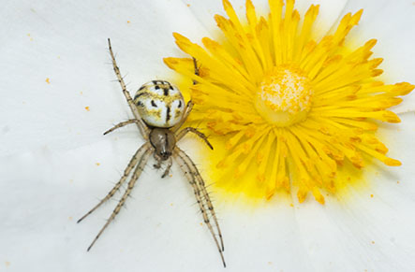
Araneid spider Mangora acalypha is known as the cricket-bat spider. It is a a common spider that is limited to the South of England. It occurs maainly in woodland and heathland. It weaves very tiny webs.

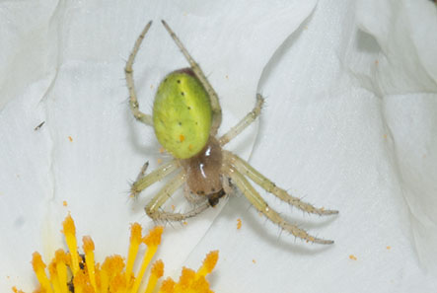
Cucumber spider Araniella cucubitina is a common small spider usually, but not always, found asssociated with oak trees. It too spins very small orb webs amongst leaves; a web maybe confined to the margins if a single leaf.

